ST. XAVIER’S COLLEGE

**(Affiliated to Tribhuvan University)**

**Maitighar, Kathmandu**



**Computer Graphics**

**Lab Assignment**

**SUBMITTED BY**

**Pratik Gautam**

**013BSCCSIT029**

**4th sem/ 2nd year**

**SUBMITTED TO**

**Er. Anil K Sah**

**Lecturer**

**Department of Computer Science**

**St. Xavier’s College**

**Date of submission: 2072/ 04/19**

**STATEMENT**

**1. Write a program to draw the following checkbox.**

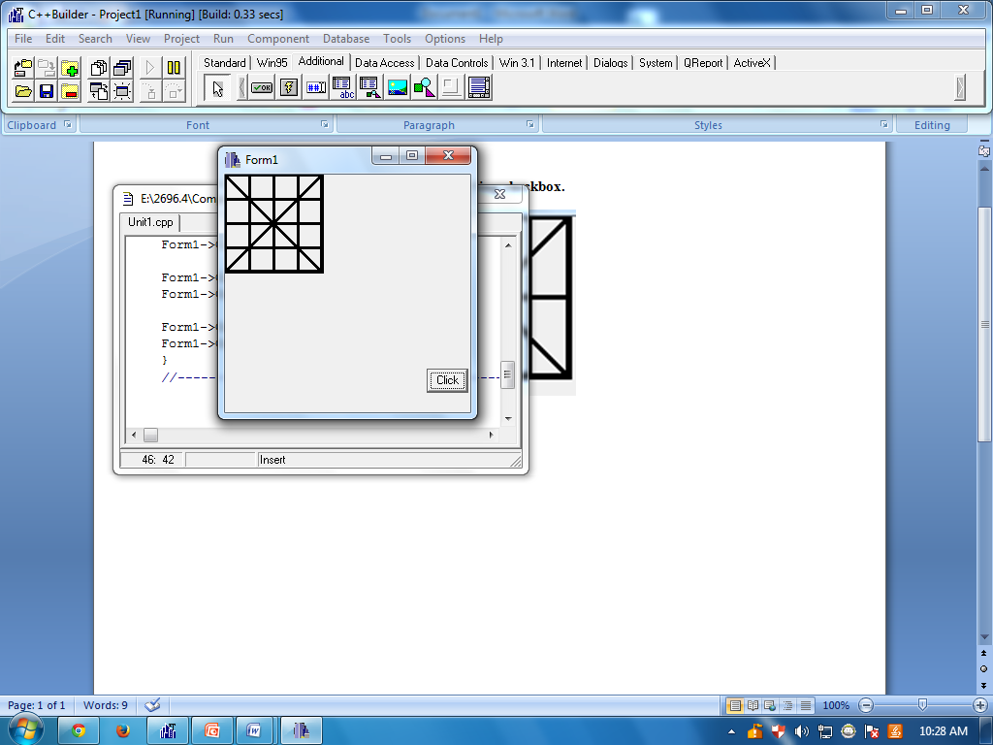

**PROGRAM CODES:**

//---------------------------------------------------------------------------

#include <vcl\vcl.h>

#pragma hdrstop

#include "Unit1.h"

//---------------------------------------------------------------------------

#pragma resource "*.dfm"

TForm1 *Form1;

//---------------------------------------------------------------------------

__fastcall TForm1::TForm1(TComponent* Owner)

: TForm(Owner)

{

}

//---------------------------------------------------------------------------

void __fastcall TForm1::ClickClick(TObject *Sender)

{

Form1->Canvas->Pen->Width=4;

Form1->Canvas->MoveTo(0,0);

Form1->Canvas->LineTo(100,0);

Form1->Canvas->MoveTo(0,0);

Form1->Canvas->LineTo(0,100);

Form1->Canvas->Pen->Width=4;

Form1->Canvas->LineTo(0,100);

Form1->Canvas->LineTo(100,100);

Form1->Canvas->MoveTo(100,0);

Form1->Canvas->LineTo(100,100);

Form1->Canvas->Pen->Width=3;

Form1->Canvas->MoveTo(0,0);

Form1->Canvas->LineTo(100,100);

Form1->Canvas->MoveTo(100,0);

Form1->Canvas->LineTo(0,100);

Form1->Canvas->MoveTo(0,50);

Form1->Canvas->LineTo(100,50);

Form1->Canvas->MoveTo(25,0);

Form1->Canvas->LineTo(25,100);

Form1->Canvas->MoveTo(50,0);

Form1->Canvas->LineTo(50,100);

Form1->Canvas->MoveTo(75,0);

Form1->Canvas->LineTo(75,100);

Form1->Canvas->MoveTo(0,25);

Form1->Canvas->LineTo(100,25);

Form1->Canvas->MoveTo(0,75);

Form1->Canvas->LineTo(100,75);

}

//---------------------------------------------------------------------------

Output:

